HALTON LIBRARY SERVICE

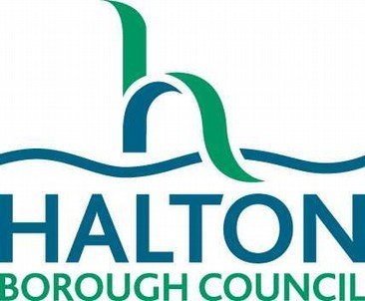
SCALE OF CHARGES
1st April 2025 – 31st March 2026

LOAN CHARGES
Talking Books Free of charge for all

FINES ON ANY OVERDUE ITEMS No charge for all

LOST & DAMAGED ITEMS Charged for at the current item replacement cost

RESERVATIONS
For items currently in stock Free of charge to all

For items approved to be bought in for stock

Adult ticket £2.75 per item
Leisure Card Holders £1.70 per item

Printing & Photocopies (per sheet):
- A4 Black & White 15p per page
- A4 Colour 40p per page
- A3 Black & White 40p per page
- A3 Colour 80p per page

Leisure Card Holders
    - A4 Black & White 10p per page
    - A4 Colour 25p per page
    - A3 Black & White 30p per page
    - A3 Colour 60p per page

LOST TICKETS
- Adults: £1.60
- Children and Leisure Card Holders: £1.00
ROOM HIRE AT HALTON LEA LIBRARY

Meeting Room | Standard Rate 2025- 206
Room 2 | £19 per hour
Room 3 | £19 per hour
Rooms 2 & 3 | £38 per hour
Room 4 | £11 per hour
Room 5 | £19 per hour
Room 6 | £19 per hour
Room 7 | £12.50 per hour

