Halton Libraries Needs Assessment – 2024

Authors : Joanne Stevens, Library Service Manager and Lorna Hulme, Digital Development Officer

Contents

- Summary …………………………………………………………………….…… 2
- Introduction and the strategic vision of Halton Library Service…. 2
- National context………………………………………………………………. 4
- Current service provision and service offer………………………..…. 5
- Data analysis…………………………………………………………………… 9
- Public engagement and consultation…………………………………… 15
- Conclusion………………………………………………………………………. 23

- Summary
A needs assessment has been undertaken to inform the future direction of library provision in Halton and the need to continue to provide a service that is compliant with statutory obligations, is focused on the needs of the community and relevant demographic groups, and is delivered within the budget available.
The needs assessment evidences the status of library service provision for Halton residents, highlighting how it is currently meeting its statutory duty. It also identifies where further improvements or changes may be proposed or required to ensure the library service is relevant, sustainable and fit for the future. It is recognised that the future of libraries is changing and transformation to meet the needs of current and future users, needs to be considered whilst being mindful of reduced resources.
A comprehensive proposal report, on proposed future library service opening hours and adjustments will be presented to Halton Borough Council Members at an Executive Board meeting, following on from a 6-week public consultation period from 27th August 2024 – 8th October 2024 and will include an Equality Impact Assessment, Needs Assessment report and report analysis dashboard from the public consultation surveys.
Transformation options for libraries to aim to ensure the following design principles, identified to develop library services, are met:
  - meet legal requirements
  - are shaped by local needs
  - focus on public benefit and deliver a high-quality user experience
  - make decisions informed by evidence
  - support delivery of consistent England-wide core offers
  - promote partnership working, innovation and enterprise
  - use public funds effectively and efficiently

- Introduction and Strategic Vision for Halton library service

Halton Borough Council is responsible for overseeing the delivery of a comprehensive and efficient library service reflecting the changing needs of local communities.
Halton libraries developed a library strategy detailing the service vision and strategy for the service from 2023 – 2028.
This 18 page insightful, ‘Libraries Strategy’ document can be viewed here: HBC Library strategy 2023 to 2028.pdf.pdf
Halton libraries Vision:
An energetic library service, inspiring learning, embracing change and contributing to a thriving, diverse Halton.
The focus of the vision is as follows:
- Energetic library service – maximising space and expanding service offers.
- Inspiring learning – for all.
- Embracing change – Implementing new technology, expanding social media and developing partnerships.
- Contributing to a thriving, diverse Halton – developing income streams, support to asylum seekers and refugee residents, developing local history collection.
- Green Pledge – adopting CILIP’s (The library and information association) Green Libraries manifesto, considering Halton libraries impact on the environment.

Requirements of statutory library service change
Previous judicial challenges to transformation decisions of other local authorities indicate that significant changes to an authority’s Library Service delivery model must be made in the context of a strategic review that is in turn informed by a needs assessment. It is considered that only through the strategic review and needs assessment process, can an authority demonstrate that any proposal to fundamentally change the service delivery model would continue to secure the delivery of a comprehensive and efficient service.
The needs assessment sets out the current Library Service provision and service offer and considers how well it is reaching its resident population. The needs assessment is based on desk top research. All aspects of the Council's statutory public library service are within scope of this needs assessment.
The needs assessment derives its findings from a body of evidence that includes:
• Demographic profiles (age and socio-economic) of library active users and library catchment populations.
• Indicators of deprivation levels in library catchment populations sourced using Office for National Statistics (IMD) data.
• Distances and travel times between each library service point
• Patterns of library activity sourced from the Library Management System, computer booking system and locally collected library data.
Ambition for Libraries (Libraries Deliver: Ambition for Public Libraries in England 2016 to 2021 - GOV.UK (www.gov.uk)) , whilst providing guidance, does not provide a simple formula for defining a library service. The report states that a comprehensive and efficient service should consider:
• accessibility (physical, virtual and outreach)
• quality (mapped to local needs)
• availability (including opening hours)
• sustainability (including value for money)

- National context
In 2016, the national Libraries Taskforce published Libraries Deliver: Ambition for Public Libraries in England 2016-202. (Libraries Deliver: Ambition for Public Libraries in England 2016 to 2021 - GOV.UK) In which it sets out the strategic vision and commitment to public libraries in England. It recognised the challenging times that councils are facing in running Library Services and calls for radical thinking to protect frontline library services, acknowledging the need for councils to work in 'new and different ways' to 'thrive and not just survive'.
The Library Taskforce described libraries as vital community hubs - bringing people together and giving them access to the services and support they need to help them live better. The report sets out an ambition for individuals to:
• choose to use libraries, because they see clear benefits and positive outcomes from doing so.
• understand what library services offer, and how they can make the most of what’s available to them.
• be introduced to new ideas and opportunities, then given confidence and quick and easy access to tools, skills and information they need to improve their quality of life.
• receive trusted guidance through the evolving information landscape and build the skills needed to thrive in a changing world.
Libraries Connected and partners including The Arts Council and The Reading Agency state that they are committed to keeping library services relevant and accessible.
The new Universal Library Offers cover:
- Culture and creativity
- Health and wellbeing
- Information and digital
- Reading
To deliver these ambitions, councils are encouraged to use seven common design principles to develop their library services which are as follows:
• meet legal requirements
• shaped by local needs
• focus on public benefit and deliver a high-quality user experience
• make decisions informed by evidence, building on success
• support delivery of consistent England-wide core offers
• promote partnership working, innovation and enterprise
• use public funds effectively and efficiently

Equalities Duties
Local Authorities have a duty when planning and delivering services to give due regard under the Equality Act 2010 to consider how different people will be affected by their activities, helping them to deliver policies and services which are efficient and effective; accessible to all, and which meet different people's needs.

- Current service provision and service offer

Halton libraries’ aim is to provide an energetic, diverse service with an inclusive offer across all of our communities.
Halton library service is currently delivered through four public libraries and as an outreach service across the Borough, this includes the Community Library Service our bespoke offer to care and residential homes, and the Home Library Service, to provide services to those unable to access our buildings.

Current provision:
Halton libraries:
- Runcorn – Halton Lea Library and Runcorn Library
- Widnes – Ditton Library and Widnes Library
Home Library Service – a borough wide service for residents unable to access a local library.
Online services – a range of online services including the lending of e-Books and e-audio books.
The service is an early adopter of new technologies including open source software solutions, embracing innovation to improve customer experiences and financial efficiency.

The library service is a key resource for our community, providing access to books, learning opportunities, cultural activity, and information. The buildings are important meeting spaces which offer a welcoming, neutral environment and host a range of events and opportunities for the whole community.

The table below signifies Halton libraries offer to National Libraries Taskforce outcomes, and indicates potential customer impacts associated with each offer.

DCMS National Libraries Taskforce Outcomes | Halton Council Vision | Library Service Offer | Customer Impacts
Improved Reading and Literacy | Supporting families. Investing in Early Years, education and youth provision.  Continue to remove barriers to education and employment. | Reading and Literacy  General and specialist book collections.  Targeted literacy programmes including Read Now Write Now.  Reading Groups for adults  Rhymetimes in all libraries  Book start packs.  Reading and literacy events.  Summer Reading Challenge each Summer | Improved literacy skills.  More confident reading  Speech and language development.  Positive parent/child engagement  A love of reading
Healthier and Happier Lives | Improving health, promoting wellbeing and supporting greater independence. | Safe and welcoming spaces.  Specialist book formats including Dyslexia Friendly.  Self-help book collections.  Reading Friends  Wellbeing Wednesday and other groups for social connections.  Digital support to reduce digital exclusion.  Programme of events for children. | Reduced social isolation  Safe spaces for meetings  Increased social interaction  More positive outlook and increased self esteem
Improved Digital Access & Literacy | Digital inclusion for all where everyone has the tools, skills and confidence to thrive in the digital era.  Help people access the Internet and improve their digital skills so everyone can benefit from its uses. | Public PCs at no charge.  Code clubs  Digital library services: eBooks, eAudio, eMagazines  Free wifi in all libraries  IT Clinics in all libraries  Digital Champions – trained staff  Tablet lending to Home Library Service users  Digital heritage offer including genealogy sessions.  Signposting to formal digital support. | Improved digital skills  Reduced digital exclusion  Engaged with technology  Greater confidence to access information and support services online.  More confident
Greater Prosperity | Strengthen families and communities and provide on-going support to people who are likely to experience poverty, inequality and vulnerability.  Deepen Halton’s talent pool by developing, upskilling and reskilling residents. | Signposting to Adult Learning courses  Access to business resources  Volunteer and work experience opportunities for young people. | More likely to gain employment  More likely to increase qualifications, skills and knowledge  More likely to volunteer.
Cultural and Creative Enrichment | Build upon our cultural strategy which ensures Halton is s a place where culture and creativity thrives.  More events and activities for the whole community to appreciate and enjoy. Supported by a new Halton Leisure Centre, alongside improved access and facilities at the Brindley Theatre. | Art/photography exhibition space in 2 libraries.  Creative writing courses  Author talks  Events including theatre company performances | Greater connection with local community activities  Improved confidence and skills  A more diverse outlook with greater knowledge of the wider community, and cultures
People achieve their full potential and stronger, more resilient communities | Encourage healthy lifestyles for the people of Halton throughout their lives.  Offer easily accessible and integrated health care, advice and services from birth.  Seek to break the cycle of dependence on services, promoting independence in Halton.  Encouraging the creation of youth groups and invest in youth services. | Children’s literacy schemes e.g. Summer Reading Challenge.  Digital Skills support with You Can Do IT weekly sessions.  In to employment support group.  Regular information stands from variety of support services including Kooth Youth support for mental health. | Increased digital and literacy skills.  Increased likelihood of employment or progression to training course.  Increased social interactions.  Better mental health.

- Data Analysis
Halton Borough Council was created in 1974, and became a unitary authority in 1998, with the two largest settlements of Widnes and Runcorn facing each other across the River Mersey. The borough benefits from excellent connectivity and transport infrastructure. There are good road and rail connections to London (less than 2 hours by train) and Birmingham via West coast mainline. Similarly there is good proximity and access to airports at Liverpool and Manchester and to the Merseyside seaports.
Halton became a part of the Liverpool City Region Combined Authority in 2014. This is one of the few City Regions to have secured a Devolution Agreement with the Government, meaning decision making and resources around key priorities are managed locally.
- Halton population is 128,964
- 1,624 population per square kilometre
- 30% are living in high deprivation areas

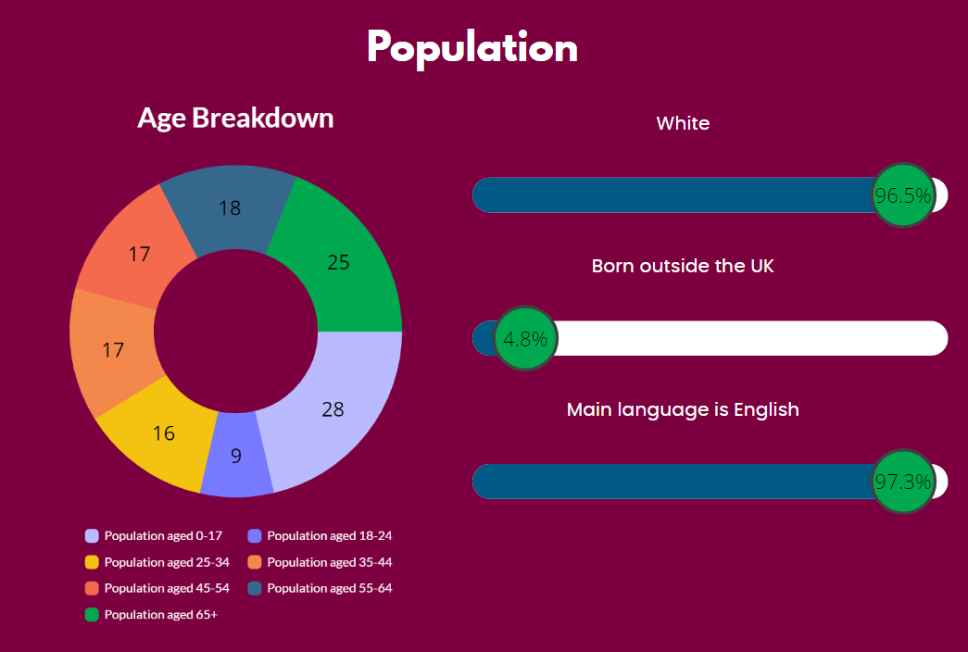
Halton Population Age Breakdown

0-17 years 21.4%
18-24 years 7.2%
25-34 years 12.6%
35-44 years 16.83%
45-54 years 13.2%
55-64 years 13.6%
65+ years 19.0%

Halton Boundaries
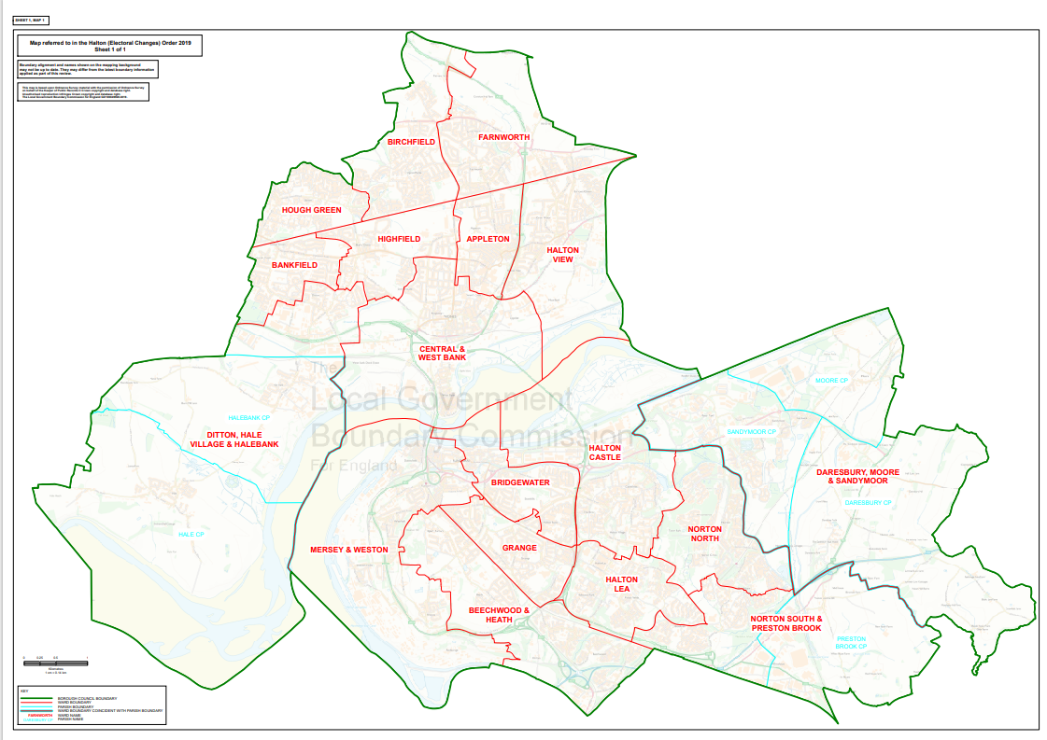

Library Membership
- Halton libraries have 79,590 members.
- Active members between 04/09/2023 and 04/09/2024 = 6,468 members.

Library Membership by branch
- Ditton Library 6,646
- Halton Lea Library 33,525
- Runcorn Library 8,119
- Widnes Library 31,300

Halton Lea Library has the largest membership with 42.1%

Library Membership by Age

The percentage of Halton members is as follows:

- 0-4 years -1.95%
- 5-12 years -11.15%
- 13-15 years -4.42%
- 16-17 years -2.06%
- 18 – 64 years -67.6%
- 65+ -13.3%

Deprivation
Overall, Halton is ranked the 39th most deprived local authority in England, out of 317 local authorities with all 4 of our sites located in deprivation areas.
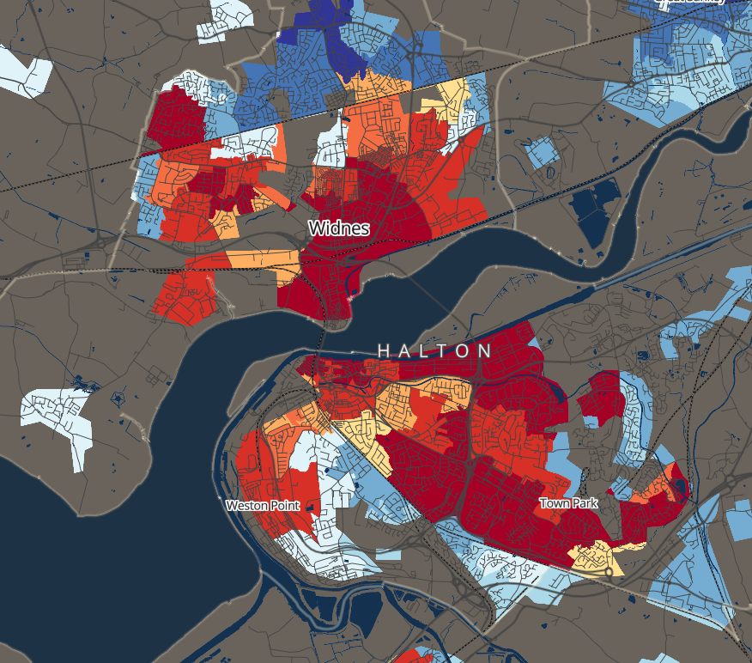
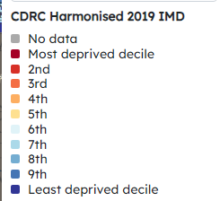

PC Use by Branch

Halton Lea Library ( WA7 2PF) in Runcorn has the highest percentage of PC usage with 48%. (01 April 2023 – 31 March 2024). It is also in an area of high deprivation.
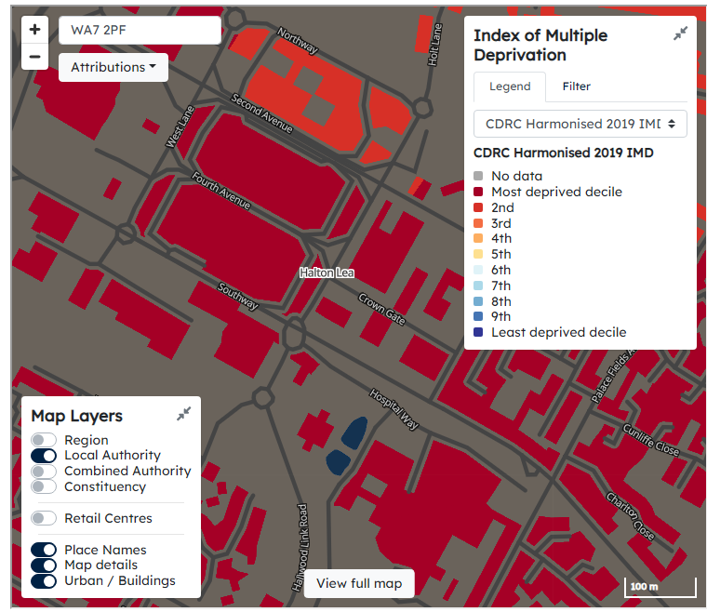
Widnes Library (WA8 7QT) has the second highest pc usage and is also in an area of high deprivation.

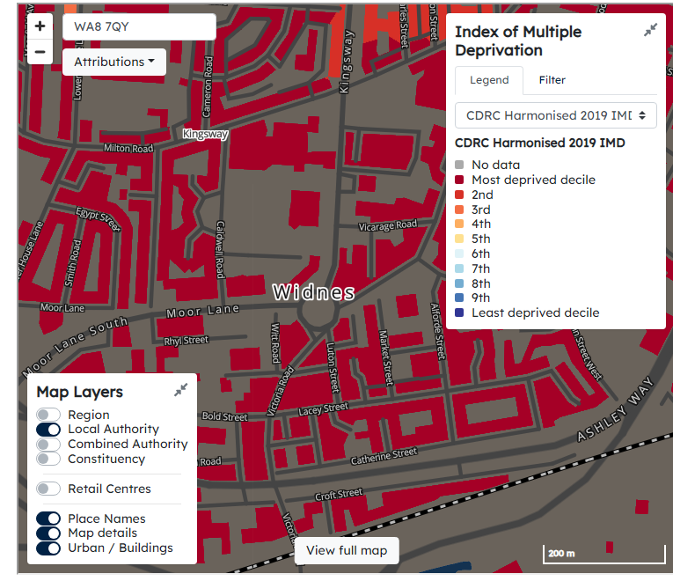

Book Issues by Branch

Halton Lea Library has the highest number of book issues with 42% (01 April 2023 – 31 March 2024)

- Public engagement and consultation

Library Service Opening Hours Consultation
Halton library service opened a 6 week public consultation window from 27th August 2024 – 8th October 2024 and engagement was encouraged via a range of mechanisms and formats. This was promoted and distributed broadly to ensure as wide and diverse of an audience as possible was reached and in turn a good response rate was received.
A full example of the consultation which showcases all proposed changes, is included below.

Opening Hours Public Consultation

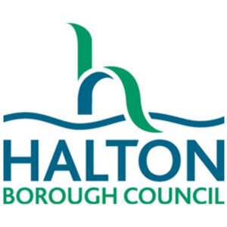
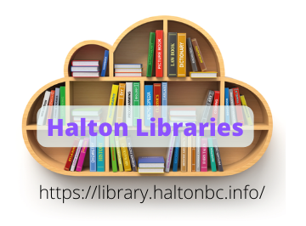
Halton Library Service Consultation

How people use our libraries is changing. We need to consider how best to provide a library service that responds to the changing library user needs, that continues to meet our statutory duty and is mindful of reduced resources.

A review of Halton Borough Council’s library service may result in budget savings for the council while still keeping all four of the borough's libraries open. The council must make significant efficiencies over the next 3-year period. This means the council will have to make tough budgetary decisions around the delivery of services.

However, the council is clear that it does not want to close libraries and is considering making some changes which would help make libraries more sustainable and cost effective. The Public Libraries and Museums Act 1964 requires the council to provide a comprehensive and efficient library service for all those who live, work or study and want to access the service in the Borough.

We are looking at the services offered by our libraries and how they work, to see if there are ways to reduce costs while providing a comprehensive and efficient service for our users.

We are now consulting on our library service opening hours to provide a more consistent offer across the library sites. Information, along with data on local needs will be used as the basis for a review by the council.

Cllr Nolan (Executive Board Member Employment, Learning and Skills and Communities) said:
“I’m proud to have libraries within my portfolio, they offer a great service to our users, from libraries within our communities to the Home Library Service. I’m very supportive of the library service and everything it offers. As with all council services, the library service has to ensure it can continue to meet the needs of the community and provide best value for money.
The consultation is important to ensure that any decisions are informed by the views of the community. All responses to the consultation will be analysed and no decisions will be taken until after all the findings have been considered.''

We want to hear your views on the proposals and also any alternatives to be more efficient.
The consultation takes the form of a short questionnaire which will be available in all four Halton libraries, Direct Links, community centres, the library service and the council's websites and will be circulated as widely as possible.

The consultation opens on 27th August and closes on 8th October 2024. If you require any further information please contact hlelib@halton.gov.uk
Ditton Library
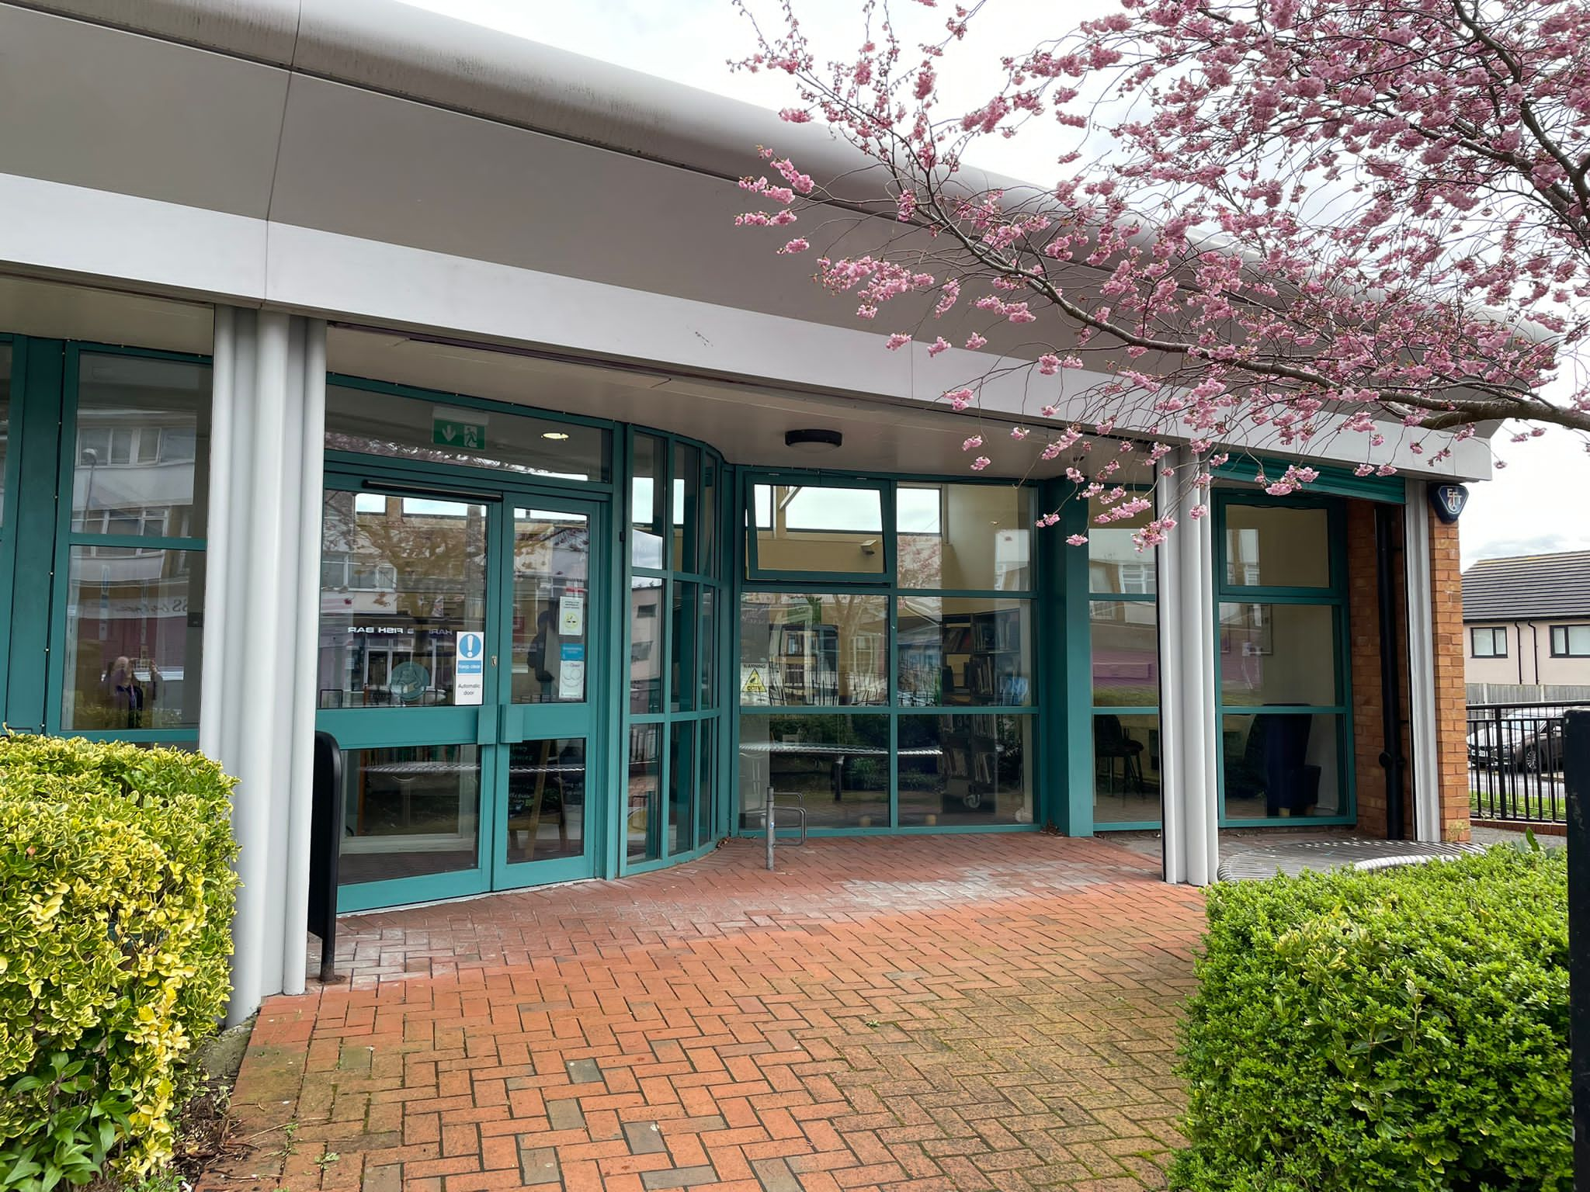
Existing Hours Proposed
Monday 10-5pm 10-5pm
Tuesday 10-6pm 10-5pm
Wednesday closed closed
Thursday 9.30-5pm 10-5pm
Friday 10-2pm 10-2pm
Saturday 10-2.30pm closed

Runcorn Library
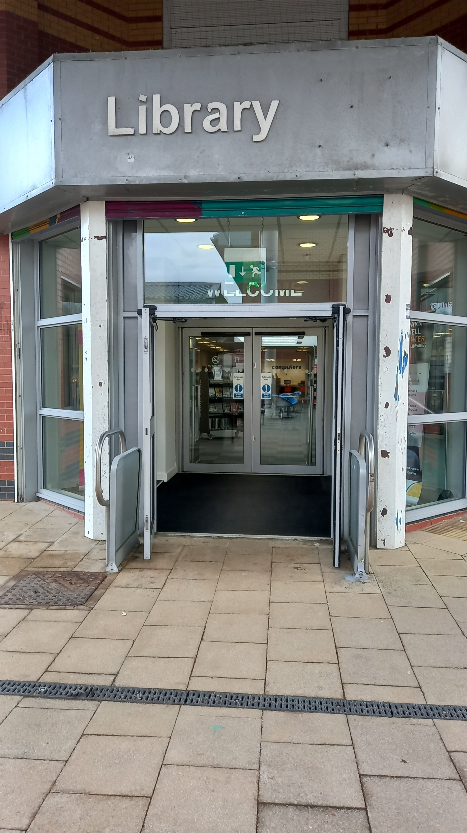
Existing Hours Proposed
Monday 10-5pm 10-5pm
Tuesday 10-6pm 10-5pm
Wednesday closed closed
Thursday 9.30-5pm 10-6pm
Friday 10-5pm 10-5pm
Saturday 10-2.30 closed

Widnes Library
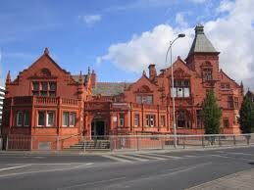
Existing Hours Proposed
Monday 10-5pm 10-5pm
Tuesday 9-7pm 10-6pm
Wednesday 10-5 10-5pm
Thursday 9-7pm 10-5pm
Friday 10-5pm 10-5pm
Saturday 10-2.30pm 10-2pm

Halton Lea Library

Existing Hours Proposed
Monday 10-5pm 10-5pm
Tuesday 9-5.30pm 10-5pm
Wednesday 10-5pm 10-5pm
Thursday 9-5.30pm 10-5pm
Friday 10-5pm 10-5pm
Saturday 10-2.30pm 10-2pm

Question 1 - Do you use Halton Libraries? If no please tell us why.

Yes No

Question 2 - Which library do you use the most and when? Please tell us why.
Halton Lea Morning

Widnes Afternoon

Runcorn Evening

Ditton Weekend

Question 3 – If we made these proposed changes to our opening hours how would this impact you?

Question 4 – What improvements or changes would you like to see to our library service?

Question 5 - The Library Service budget for 2024/25 is £2,180,740. This equates to £16.91 per person, per year based on the current Halton population. What are your thoughts on this?

Question 6 – Do you have any suggestions for how we can make cost savings in the library service?

Please use the box below for any further comments.

Thank you for taking the time to complete this survey. Please return to a member of Halton Borough Council staff.

Consultation Survey Distribution List
The consultation document was shared with the following:

Halton Libraries
Halton Libraries x 4 sites
Home Library Service users
Halton Libraries website
Halton Libraries social media channels
Halton Libraries reading group members

Groups and Organisations
Castlefields Health Centre
Halton Housing residents
Asylum seekers and Refugees through Halton Borough Council
Halton Community Centres (x 6) paper copies and social media channels
Register Office via paper copies and social media channels
Halton Direct Link (x 2, Widnes and Runcorn branches)
Riverside College
All Halton primary schools
All Halton secondary schools
All Halton special schools
Age UK
Halton College
Halton Adult Learning
Domestic Violence Groups
Equality, Diversity and Inclusion Officer at Halton Borough Council
Halton Carers Centre and disability charities
Halton CAB
Tutors in the local authority
Mailing Lists
Community Development Mailing list
Partners In Prevention mailing list
Halton Council Health Team mailing list
Halton Borough Council all staff mailing list, including Halton Chamber of Commerce

Newsletters
Halton and St Helens Voluntary and Community Action newsletter
Halton Healthwatch monthly bulletin
Halton Libraries monthly newsletter

8 public consultation, drop in, face to face sessions were also held, across sites at differing times with the Library Service Manager.
This widespread dissemination of the consultation resulted in 718 responses being received and a report analysis was then produced by the Research Data and Insight team in Halton Borough Council and the details of such can be viewed here:
Library Opening Hours
- With the majority (57%) agreeing with the proposed opening times
The top 5 reasons for using a Halton library being identified in the consultation report as:
- “To borrow books as there is a large choice, cheaper than buying new, can’t afford to buy new, it is a sustainable approach, great range, the monthly book displays, books for hobbies and education.”
- “Bring own children, grandchildren to borrow books, school holiday events, clubs and groups - rhyme time, science club, dungeons and dragons, Lego, craft. It is free.”
- “Study /course work, ancestry / family records, journals, reference, maps, research for work, local information.”
- “For example book club, Good Yarn, Knit and Natter, IT Club, Brownies, Outreach, Home Education, Coffee Mornings, Men’s Shed, run groups.”
- “To print and photocopy, do not have equipment at home.”
- events, clubs and groups - rh
A full breakdown of all comments and suggestions can be found here:
Microsoft Power BI

Loneliness Survey, Halton Borough Council.
In Spring 2024 Halton Borough Council conducted a survey relating to loneliness. The results were used to create a loneliness prevention strategy for Halton. They received 261 responses.
Of those who responded 37% feel they lack companionship often, 36% feel isolated from others often and 28% feel lonely often.
Halton libraries have accessed funding to employ an Activities Co-ordinator who is tasked with implementing initiatives to tackle chronic loneliness. Halton libraries have introduced a weekly adult meet up group, Midweek Meetup, aimed at all, a Men’s Shed meet up session aimed at providing men with an inclusive space to discuss a variety of topics to improve their health and wellbeing and a Together Unlimited session, to unite people with disabilities or limitations.

Transformation
Halton Borough Council currently has a transformation programme in operation who compiled footfall data and analysis over a 3 month period in 2023, across all library sites to provide us with key data to support proposals.
Data to support Saturday footfall at Runcorn & Ditton (recorded over a 3 month period)-
- Runcorn library, total Saturday footfall = 994 people
- Ditton library, total Saturday footfall = 435 people
In comparison for the same period,
- Halton Lea library total Saturday footfall total = 2,412 people
- Widnes library total Saturday footfall total =1,396 people
Distance and locations
- Widnes library is 1.8 miles away from Ditton walking or 2.4 miles by car.
- Halton lea library is 2.0 miles away from Runcorn walking or 2.4 miles also by car.
Emphasising the close proximity of sites and the library provision that would remain available on Saturdays.

- Conclusion
In defining its approach to further library service transformation, Halton Borough Council is led by precedent, comments made by the Secretary of State and the outcome of High Court Judgements, which define a legal landscape of library change in which:
• there is no clear or absolute definition of what constitutes a, 'comprehensive and efficient' library service as described in the 1964 Public Libraries and Museums Act; nor is there an agreed mechanism for defining the need for that service;
• the only way that a library authority can demonstrate that the transformation of its library service will continue to meet its statutory duty of delivering a 'comprehensive and efficient' service, is through a strategic review of that service which is underpinned by a needs assessment.
• an authority must make the required value judgements to establish a needs assessment framework which describes the need for its library service.
• a 'comprehensive and efficient service' is not determined by the number of libraries provided; but must be understood in the context of available budget.
Against this legal background, and based on findings from the need’s assessment undertaken and documented in this paper, the following recommendations are put forward to shape Halton’s approach to further library transformation:
- Keep library services progressive and operational
- Move to a more consistent opening hours model
- Reduction in whole of service total opening hours by approximately 20 hours from current opening hours total
- Reduce late night provision
- Achieve environmental and energy savings, realised by the proposed changes to our opening hours, for example less consumption
Prioritise need
The Councils approach to transformation must prioritise resources in those areas which have the greatest need and for the library service, work is needed to address under representation of individuals by socio-economic groups and to understand why some people are not using some or all areas of the service. Halton library service possess a proactive Outreach team who are working to ensure the library service is as far reaching as possible, across all areas of the Borough.
Value for money
The proposed changes must aim to reduce costs and seek to increase participation in services that libraries currently provide. Within any transformation, the service must deliver a service offer that reflects the Council’s objectives, whilst reflecting upon national standards of delivery.
Public response to any suggestion of changes to library services and analysis of library use, indicates that there is a need to continue to support a comprehensive book lending collection. Libraries are valued by those who use them, however the needs of the persons not using library services also need to be considered.
The consultation report analysis produced a ‘top 5 reasons for using’ a Halton Library and a ‘top 5 reasons for not using a Halton Library’, both are included below.

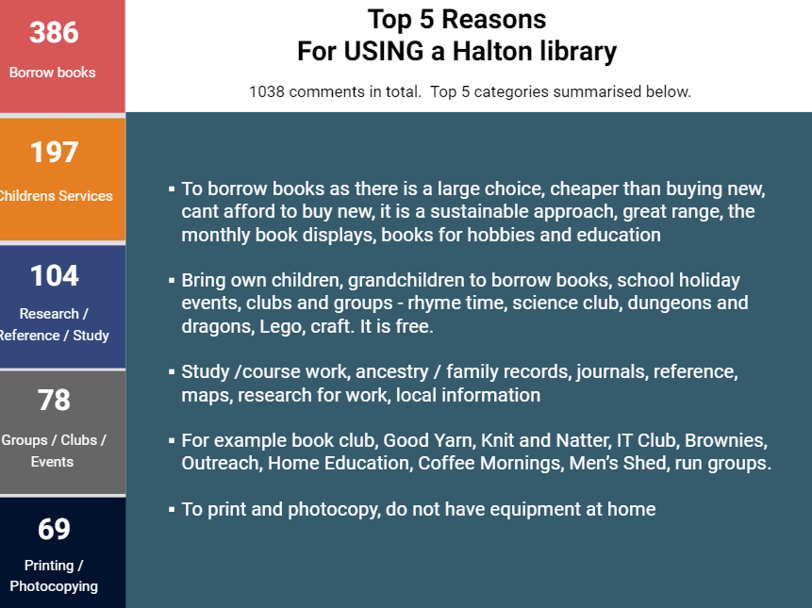

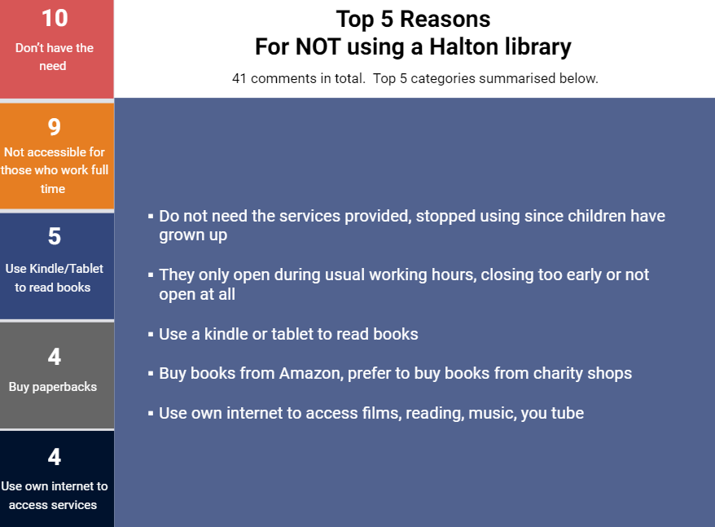

Access to free computers and internet access remains a key part of the existing library offer, however it is recognised that demand may change or develop. This aspect of delivery should be explored and advanced further as a wider digital inclusion offer in the future of Halton libraries offers.

