**Questions**

**How can I improve the soil in my garden?**

Mulch the beds in the autumn. You can make your own mulch by cutting up any leaves, bark, cuttings from tidying etc.

Make leaf mould. At this time of year you can collect the leaves and put them somewhere to rot down. It’s better to shred the leaves. Put them in a plastic bag, water them if they’re dry and make holes in the bag. Seal it and leave it somewhere to break down for a year. This can then be used as a mulch.

**Recommend a natural bug control?**

Garlic is an effective deterrent. Steep garlic in water and then decant into a spray bottle and use regularly on plants.

**How do I grow alstroemeria in a very wet garden?**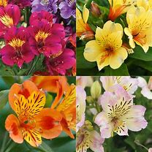

These have grown really well at the Wonky garden.

They need room to spread. Try planting in a half metre tall raised bed. Add grit to the soil to absorb some of the moisture and plant the bulbs deep (about the depth of 4 bulbs). Then mulch.

**What’s wrong with my Bramleys? They haven’t done well this year and have dots on them.**

There is likely to be a fungus on the apple tree. This year has been wet and warm and has encouraged fungus development. The advice is to prune the tree between November and March and take off the affected branches. May have to treat with fungicide.

**What is a hot compost bin?**

You can add anything to the hot compost bin, including all food waste. It is completely sealed and works faster than a normal compost bin. The heat kills off weed seeds as well.

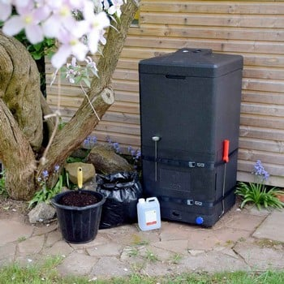

**Can you put teabags in the compost bin?**

A lot of teabags are now biodegradable. Just need to check the pack for a green label. Used coffee grounds are also good for compost.

**How often should I feed the garden?**

The gardeners recommended putting a mulch down over winter and then in the spring, put down manure and seaweed. They don’t tend the plants after that. Too much feed can cause too much acceleration of growth and produce too much foliage, rather than flowers.

Timing is important.

**No mowing areas**

Some gardeners leave an area of lawn to grow, to encourage wild plants and insects.

There was a warning about checking for hedgehogs before cutting it again. Millie always makes some noise to wake them and leaves a few minutes for them to move before she starts to mow. They tend to nest on the edges of a lawn.



**Can I keep blackberries in the garden without the plants getting out of control?**

Yes, but they need to be pruned right to the ground every winter to control them.

**I have a shady garden with moist clay soil. Recommendations for plants that will grow?**

To create a better drained soil, break it down and mulch it over the winter. There are a number of plants who like shade – Goatsbeard, astilbe, ornamental grasses, hellebores, anenomes and calendula.

**Ideas for good tree for a small garden?**

There are dwarf varieties of a number of trees, including fruit trees. Other suggestions are acer, maple, Silver Birch and Sorbus.

**Slugs – what can I do about them eating my plants? Is there a natural/kind way to get rid of them**

There were a number of suggestions. Grow garlic and chives near the plants that are the most liked by slugs. Use crushed eggshells, as slugs don’t like moving over them.

Encourage the birds to the garden to eat the slugs by increasing the biodiversity of the garden

**Best way to get moss off a lawn?**

Make sure you have the right type of grass for your garden.

Scarify the lawn and look at natural control for moss.

**My apple tree only produces fruit every other year. It’s never been pruned could that be the problem and when’s the best time to prune?**

That probably is caused by the lack of pruning. The best time to prune the tree is between November and March. You can cut up to 25% of the tree every year and it will grow back healthier and should start to produce fruit annually again. There are a number of picture guides on the internet to help you prune. <https://www.rhs.org.uk/fruit/apples/pruning-made-easy>

**Could you give us some examples of a hardy houseplant ? The ones least likely to be killed off?**

It is generally the way that a houseplant is cared for that helps it to survive.

Here are some tips

To avoid water accumulation from overwatering, add an inch of gravel to the bottom of the pot.

Use houseplant compost, with grit. Another good mix is coco hair, perlite and grit, with a chunky compost.

Try not to overwater the plant

Group the plants together. This will help them create their own humidity.

Put your house plants outside in the summer in a sheltered spot that’s not too bright. They should be OK until the temperature drops below 10 deg.

Quarantine a new plant for 2 days and the leaves with neem oil to get rid of pests that may spread to other plants. (if using neem, keep the plant out of the sun for 48 hours to avoid burnt leaves)

Spider plants are easy to look after, self-seed and the baby plants can be easily potted up.

