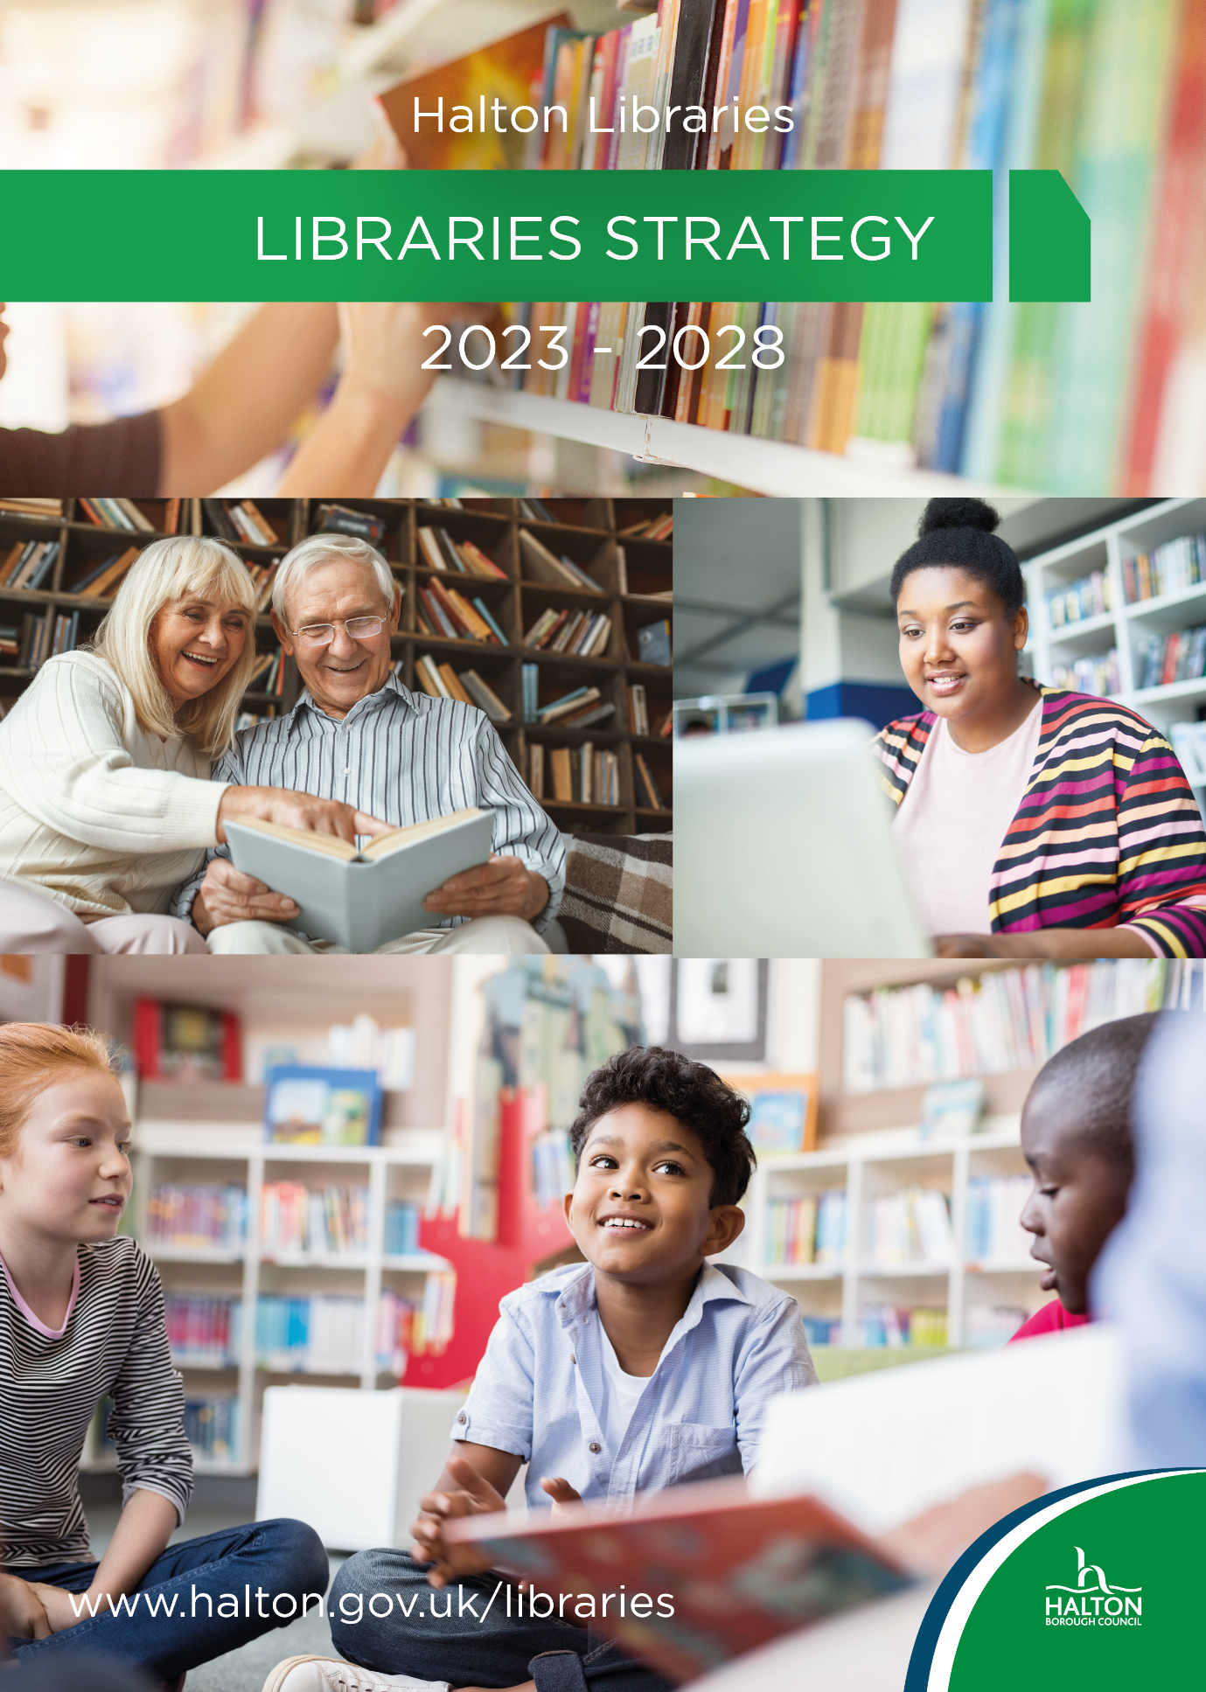
Halton Libraries Strategy – 2023/2028

Introduction

Halton Libraries’ aim is to provide an energetic, diverse service with an inclusive offer across all of our communities. This strategy provides a framework for the future of the service, so that Halton Libraries can continue to meet the needs of local communities and support the aims and objectives of the Council.

Background

Halton Library Service is delivered through four public libraries and as an outreach service across the Borough, this includes the Community Library Service our bespoke offer to care and residential homes, and the Home Library Service, to provide services to those unable to access our buildings.

The Service is an early adopter of new technologies including open source software solutions, embracing innovation to improve customer experiences and financial efficiency.

The library service is a key resource for our community, providing access to books, learning opportunities, cultural activity, and information. The buildings are important meeting spaces which offer a welcoming, neutral environment and host a range of events and opportunities for the whole community.

Halton Libraries’ offer

It is free to join and use Halton Libraries

- Books
Halton Libraries have over 136,000 books in stock with collections for both children and adults. There is a huge variety of topics ranging from astrology to zoo keeping with titles available in a number of formats including audiobooks. Library users can take out 20 books at a time.

- E-books and e-audiobooks
Halton Libraries’ users have access to over 40,000 e-book and e-audiobook titles via Borrowbox including the latest fiction and non-fiction bestsellers. Library users can loan 6 e-books and 6 e-audiobooks at a time.

- Dual language and dyslexia friendly collections
Halton Libraries have a selection of books which are suitable for users with dyslexia and other conditions. There are also a wide range of dual language books covering languages such as Polish, Ukrainian, Farsi and Spanish.

- Digital newspapers and magazines
There are over 27,000 digital newspapers and magazines available on the libraries’ Press Reader site. The site is free to access and content can be translated into over 250 languages.

- PCs and printing
There are more than 40 public use PCs across the four Halton Libraries. These are free to use and there are also printing and photocopying facilities available.

- Local history
The local history collections at Halton Lea Library and Widnes Library contain a wide range of materials covering the history of Runcorn, Widnes and the surrounding areas. There is also a collection of local history photographs covering events in and around the Halton Borough dating from the 19th century. Library users also have free access to Cheshire Record Office and Archives.

- Meeting room hire
There are 7 meeting rooms at Halton Lea Library that can be hired by both corporate and private groups with additional rooms for hire in Runcorn Library. There is also display and exhibition space for hire at both Halton Lea Library and Widnes Library for local individuals and community groups.

- Rhyme time and Saturday sessions
Rhyme Time sessions for pre-school children take place all year round across each library location on a weekly basis. Stories and songs are enjoyed and provide a fun and enjoyable introduction to books, reading and libraries for young children.

- Library clubs
There are a number of free clubs which are run by Halton Libraries on a regular basis which include:

Good Yarn group
Lego club
Halton memories
Reading Friends phone group
Science club
Brilliant Builds
You can do I.T.

- Games and jigsaws
There is a wide range of both adult and junior games and jigsaws, which are free to use and are available during library opening hours.

- Community Library Service
Halton Libraries provides a valuable service to the community. This includes lending collections of books to care homes and sheltered housing, delivering memory boxes to care homes and giving talks and information to community groups and organisations. We are also working in partnership with other organisations to provide specific books and services to all parts of the community.

- Home Library Service
This service ensures that people who cannot get to the library for reasons such as mobility, illness and caring responsibilities, are still able to access books, delivered to their home once a month.

Most popular adults and children’s books
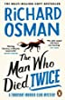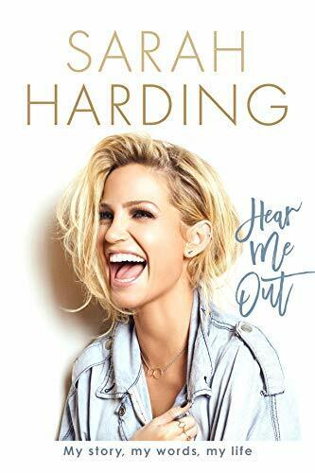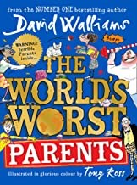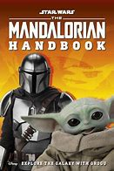
Highest loaning children’s fiction book

Highest loaning children’s non-fiction book

Highest loaning adult non-fiction book

Highest loaning adult fiction book

UNIVERSAL OFFERS

National Context
The National Universal Library Offer Framework -www.librariesconnected.org.uk/page/universal-library-offers has been developed by Libraries Connected to represent core services which our customers and stakeholders see as being integral to a 21st century public library service.

The Universal Offers are delivered in Halton and are tailored to meet local needs.

Halton Libraries’ Vision

An energetic library service, inspiring learning, embracing change and contributing to a thriving, diverse Halton

How will we deliver our vision?

- Energetic library service

Maximise the potential of the space within library buildings:
Extend the junior areas and move the teenage sections to more prominent positions in Halton Lea and Widnes Libraries.
  - Refresh the layout of Halton’s libraries to improve customer service, interaction and accessibility.

Expand our offer to school aged children across the borough:
  - Engage with primary schools to increase the membership for reception class intake.
  - Increase the class visit offer and develop a new booking system for class visits.

Improve, strengthen and ensure consistency of customer service:
  - Extend the corporate personal development for Halton Libraries’ staff.

Improve the links with internal and external partners.
Expand our Home Library Service offer:
  - Increase our customer base to reach more people within the borough

Improve information provision by introducing information hubs in all Halton Libraries.

- Inspire learning

Introduce IT help sessions in all libraries and other community settings.

Expand the number of rhyme time sessions and extend the offer to specific groups.

Develop our partnerships with the local secondary schools through promotion and activities.

- Embracing change

Maintain connections with Runcorn Old Town during the transition of Runcorn Library to the Brindley.

Extend the community library service:
  - Introduce pop-up library services in community centres.
  - Develop partnerships with local health services.

Implement Hublets at Halton Lea Library and introduce Wi-Fi printing in all Halton Libraries.

Expand our social media offer to reach more members of the community.

- Contributing to a thriving, diverse Halton

Expand the opportunities to work with other agencies across Halton:
  - Continue to develop our partnerships with business resources services.
  - Expand the partnerships that offer onsite services to users.
  - Further develop partnerships across the Halton community.

Develop the local history collection by promoting the archives service at the Cheshire Record Office and digitising the local history photograph collection.

Expand Halton Libraries’ support to asylum seekers and refugee residents within the borough.

Explore financial efficiencies.

Investigate new income streams to increase library revenue.

Implement the winter campaign every winter from 2023 to 2028.

- Halton Libraries’ Green Pledge

Halton’s Libraries are part of CILIP (the UK’s Library and Information Association) Green Libraries Network and are signed up the Green Libraries manifesto, adopting the hashtag #Green Libraries for environmental events.
We pledge to consider the impact on the environment from the way the library service is operated and where possible, reduce the impact on the planet.
Current examples include:
  - World of Books (our book buyers) are a Certified B corporation, the company meets the highest standard of social and environmental impact.
  - We regularly plan events for children and families that highlight the need to be aware of our environment and work to increase recycling and reuse items where possible (i.e. tinker table, seed planting).
  - Recycle bins are available in all libraries and staff workrooms.
  - Our libraries hold stock on climate change, the environment and nature for all users, so borrowers can access information on these topics. The libraries feature displays, quick choice promotions relating to the environment and climate change and celebrate national and global days such as Climate Day and Green Day.
  - Our couriers use the most efficient routes for deliveries to the libraries and our Home Library Service clients.
  - We are also reducing the environmental impact of our library buildings by introducing measures such as energy efficient lighting.

Home Library Service customer comments…..

"It has been brilliant during lockdown, Covid and various self-isolation for operations. I have never been missed - organisation is great those that are delivering are smiling and courteous. A brilliant service. Thank you."

"I look forward to the next date every time. Sometimes it can't come quick enough as I have read all my books and eagerly look forward to the Tuesday delivery. Congratulations to all staff and the drivers who always have a smile" 10/10 .

"Superb service, even throughout lockdown, It’s made such a difference to know library books would still be delivered. I find it excellent!" 10/10.

“10/10 scores. The selection of books is excellent. Nothing is too much trouble for the staff.”

"To all Outreach staff, thanking you for a 1st Class service which is greatly appreciated."

"To you all for a lovely service this year - 2022".

"Your service and staff have been lifesavers for me over the last 2 years. Thank you all drivers and staff." 10/10.

"Delighted with the service it helps me enormously. Thank you"

“Really happy with the service and the book selections have been fabulous. Enjoying trying new authors. Thank you!”

Strategic plan

12 month strategic plan – 2023/2024

- Extend the junior areas and provision in Halton Lea and Widnes Libraries.

- Extend the Home Library Service provision.

- Increase the class visit offer and develop a new booking system.

- Improve information provision by introducing community information notice boards.

- Maintain a service provision with Runcorn Old Town during the transition of Runcorn Library to the new extension at the Brindley.

- Provide display and exhibition areas at Halton Lea Library and Widnes Library.

- Develop social media channels.

- Improve the IT access for customers, adopting greater use of virtual storage and user friendly search engines.

- Review the library service opening and closing times, to provide the customer with greater consistency, without a detriment to the quality of the service.

- Maximise the use of #Greenlibraries for environmental events.

- Continue to promote Borrowbox and our online services, by all effective means, to ensure we reach the widest audience possible.

3 year strategic plan – 2023/2026

- Introduce IT help sessions in all libraries and community settings.

- Increase the number of rhyme time sessions and expand the rhyme time offer to specific groups.

- Increase the #Greenlibraries offer through new events, promotions and book stock.

- Develop our partnerships with the local secondary schools through promotion and activities.

- Continue to develop our partnerships with business resources services.

- Implement Hublets at Halton Lea Library and introduce Wi-Fi printing to all libraries.

- Investigate new income streams to increase library revenue.
5 year strategic plan – 2023/2028

- Refresh the layout of Halton’s libraries to improve customer service, interaction and accessibility.

- Develop a programme of climate change STEM sessions for school visits.

- Engage with primary schools to increase membership for the reception class intake.

- Improve, strengthen and ensure the consistency of the libraries’ customer service policy.

- Extend corporate personal development for Halton Libraries’ staff.

- Improve the links with Halton Libraries’ internal and external partners.

- Extend the community library service with pop-up library services in the community centres and partnerships with local health services.

- Expand partnerships that offer onsite services to users.

- Further develop partnerships across the Halton community.

- Explore financial efficiencies within the library service.

- Expand the support to asylum seekers and refugee residents within the borough.

- Implement a winter campaign every winter from 2023/2028.

- Promote the archives service at Cheshire Record Office and develop the local history collection.

- Explore options for digitising the local history photograph collections within the service and make them accessible to all.

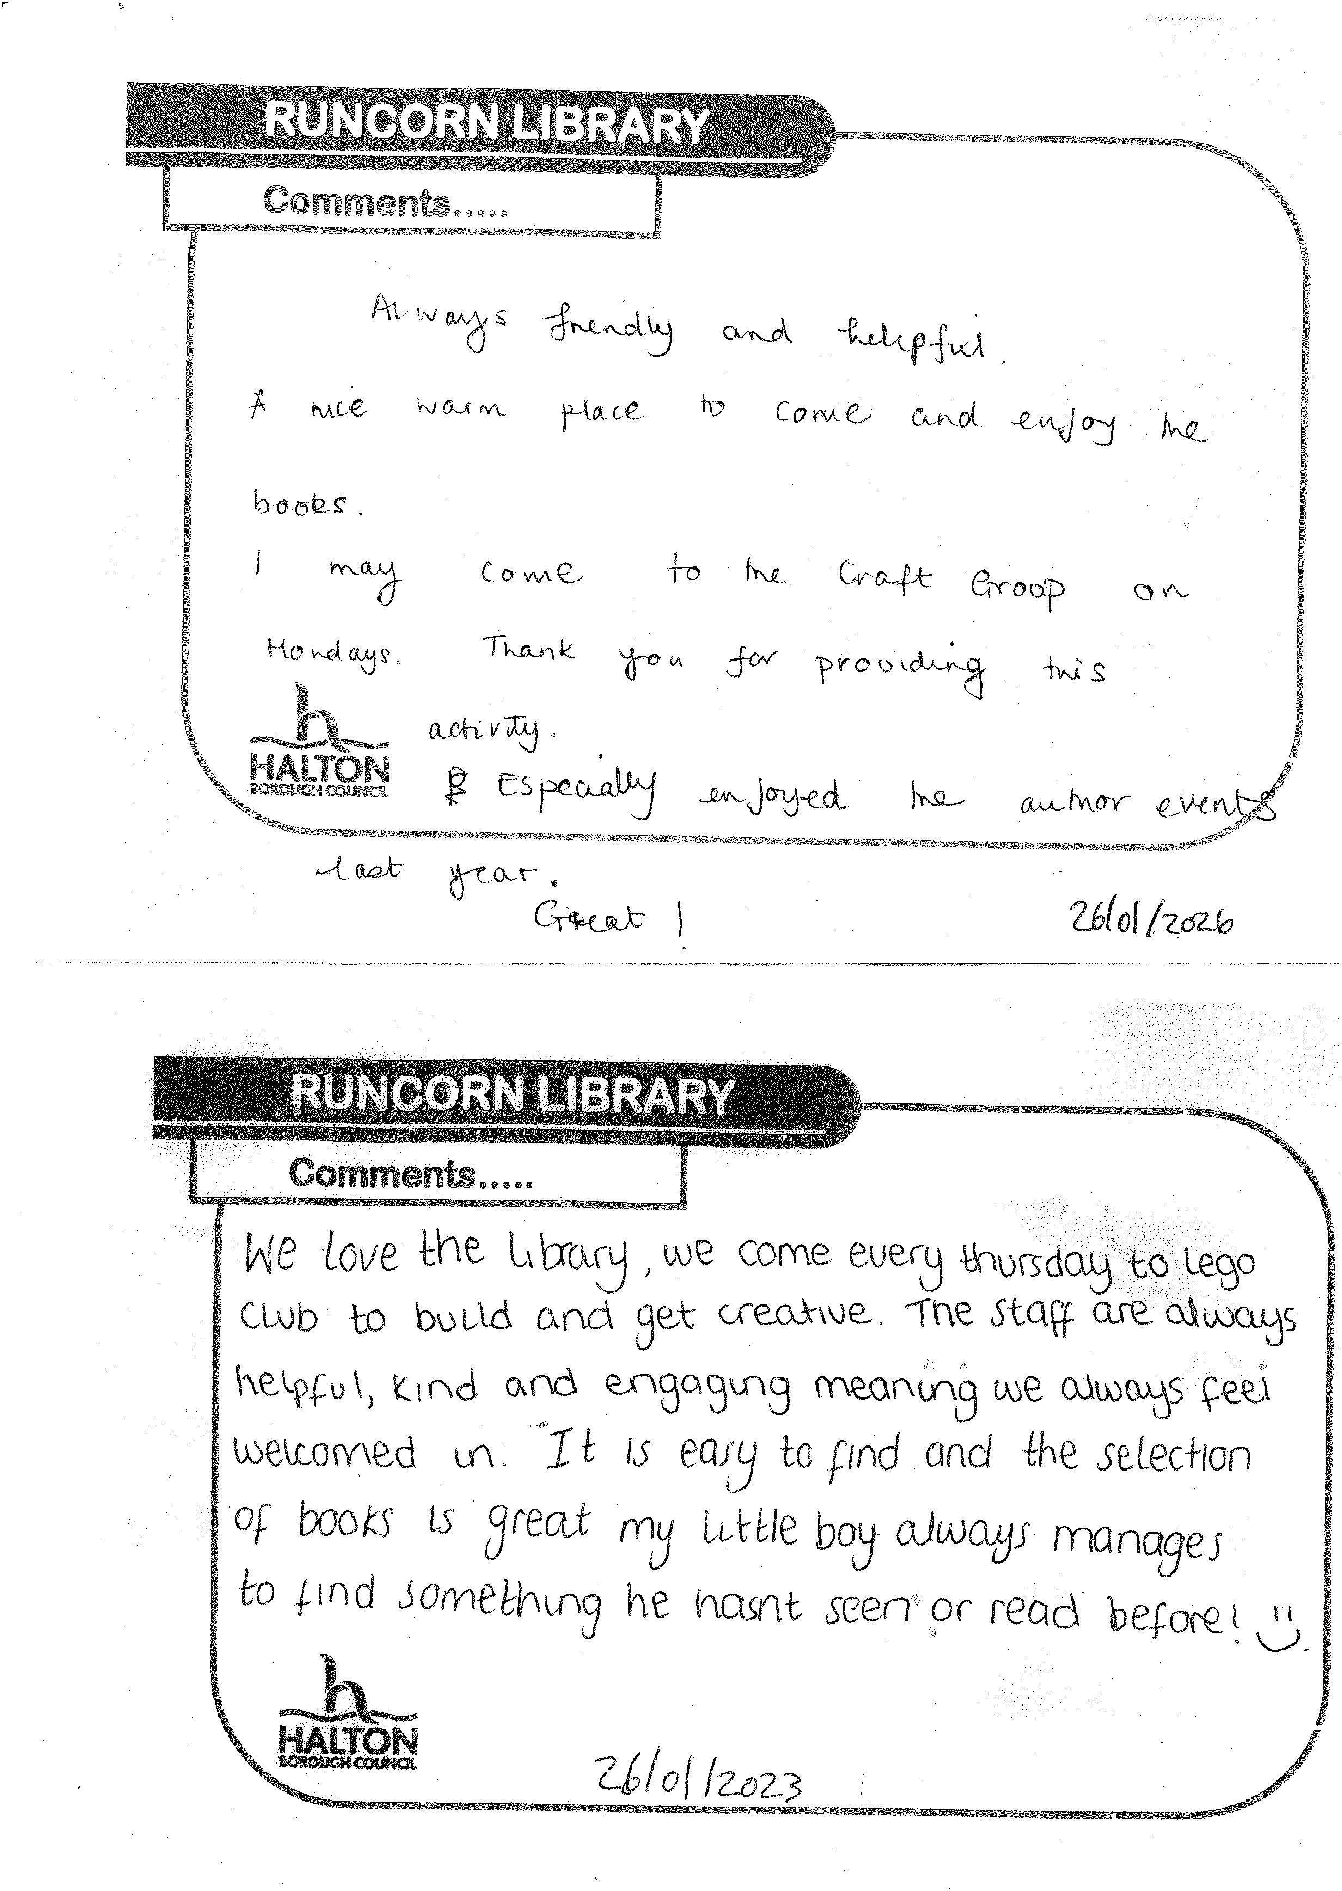
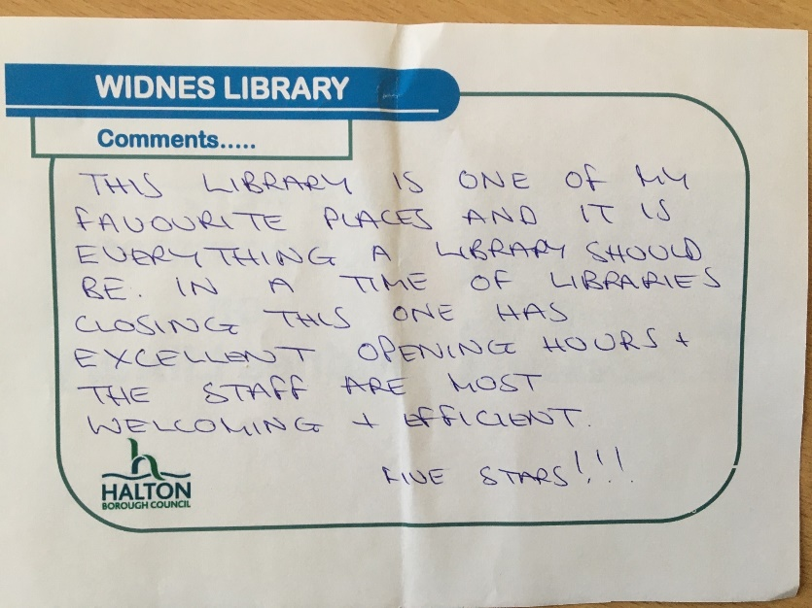

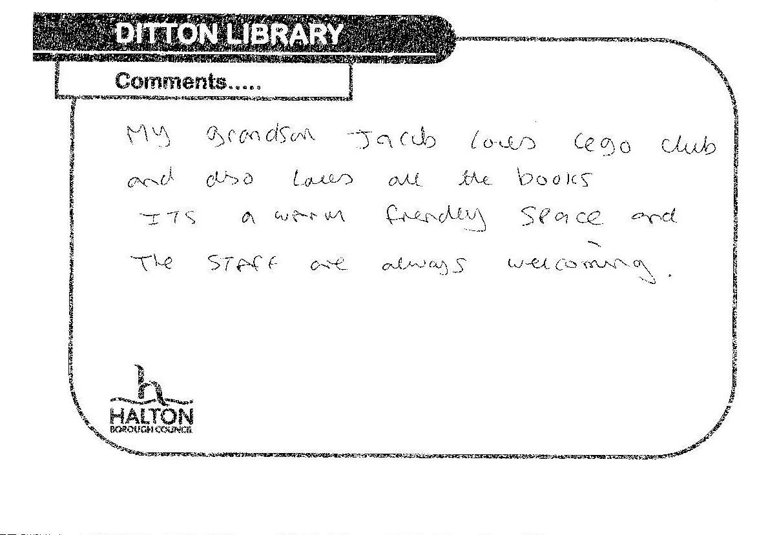
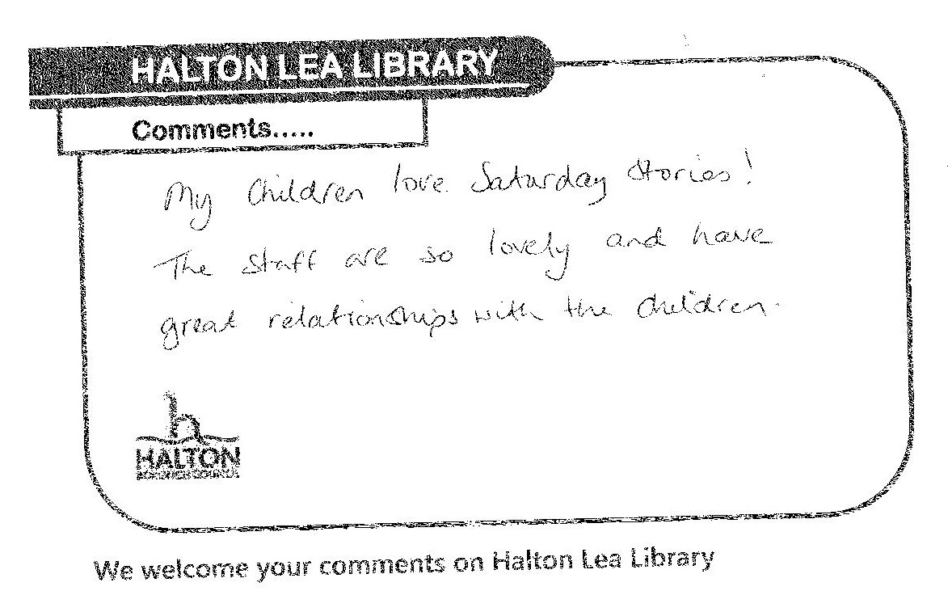

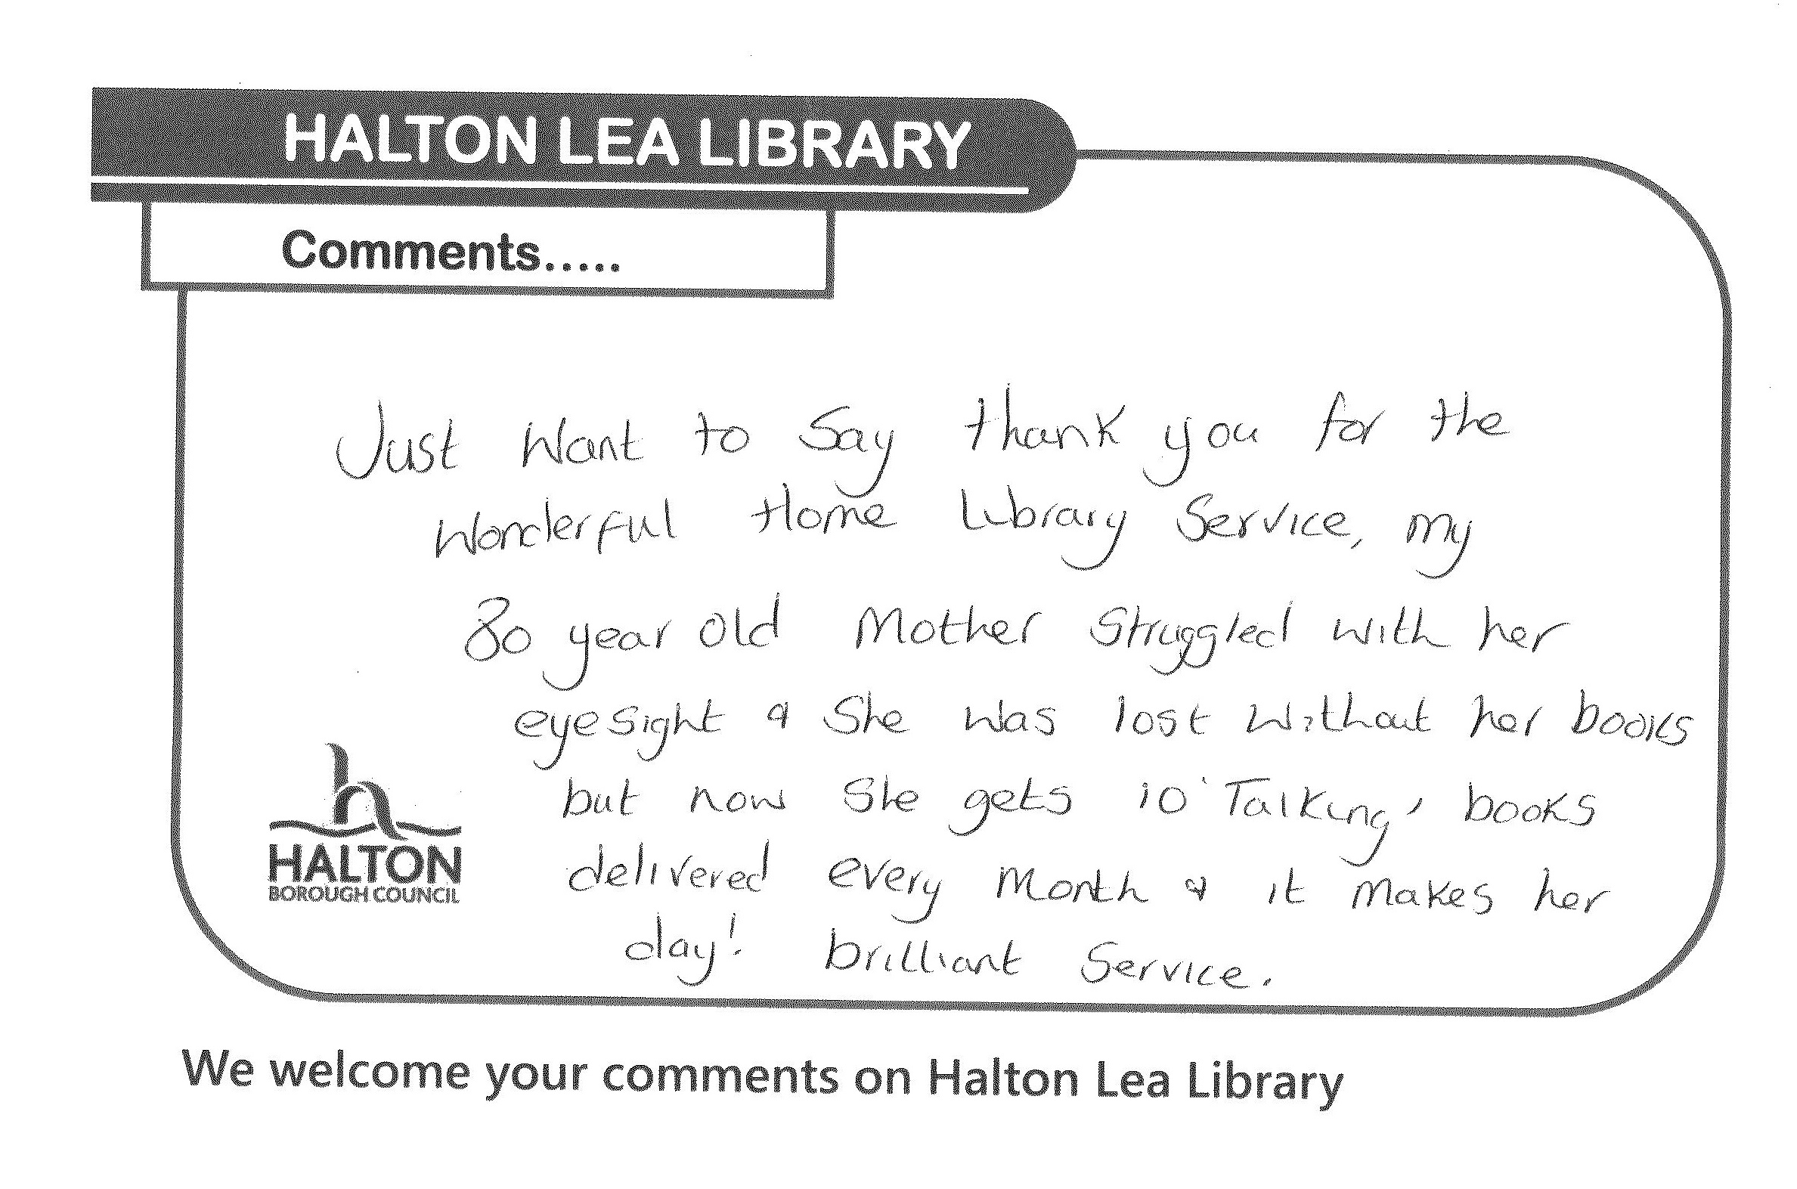
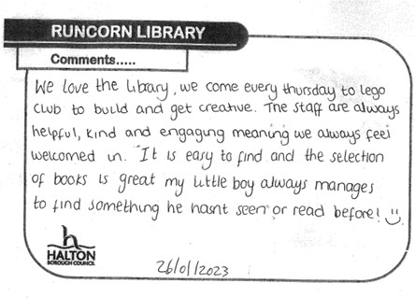

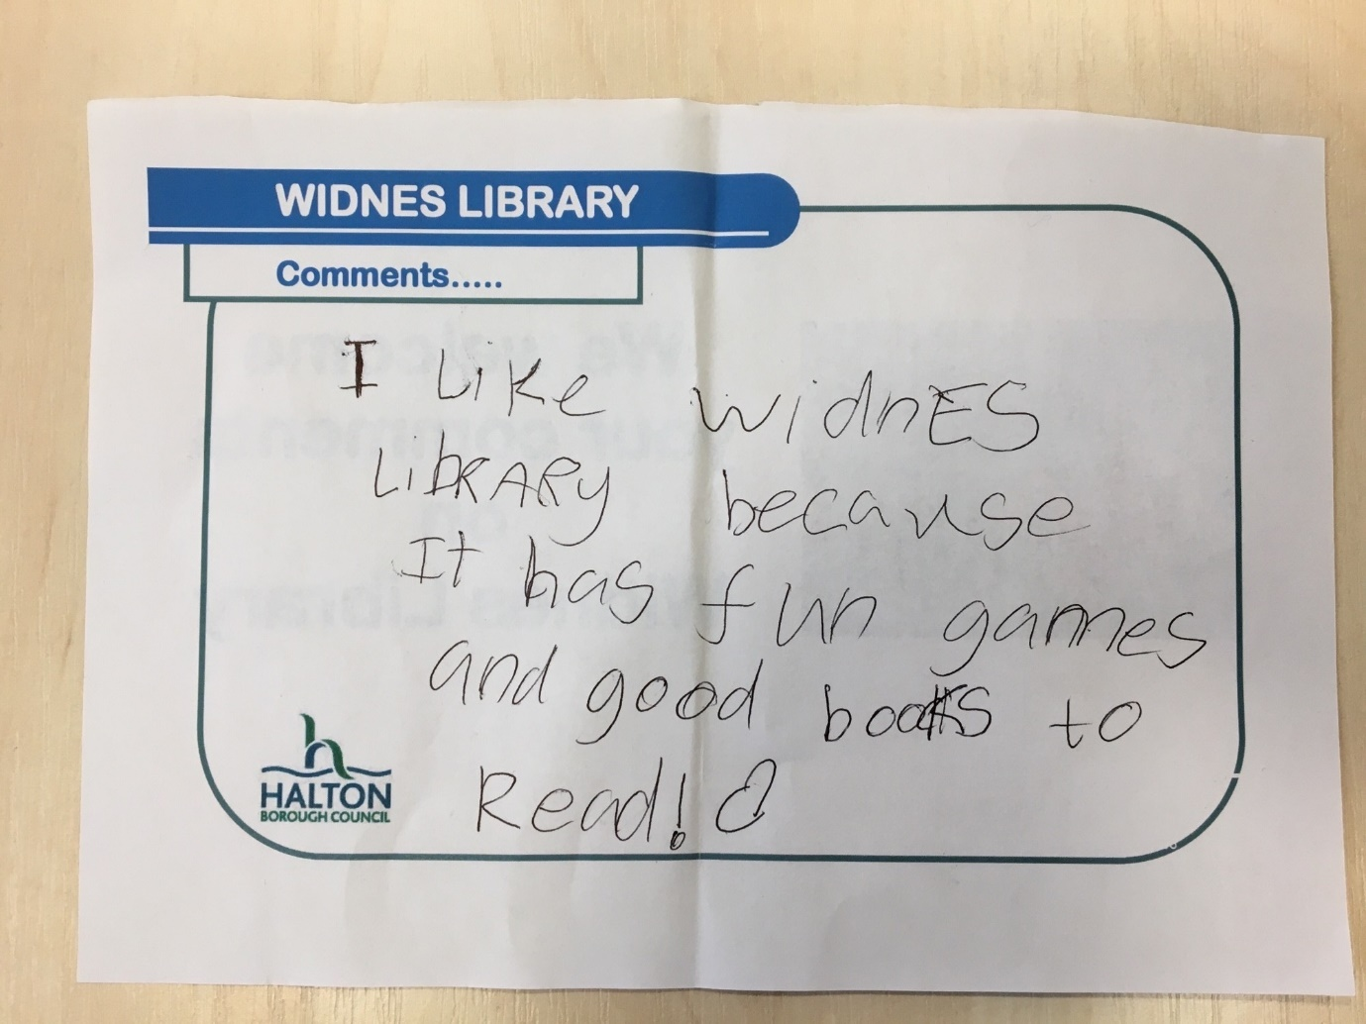
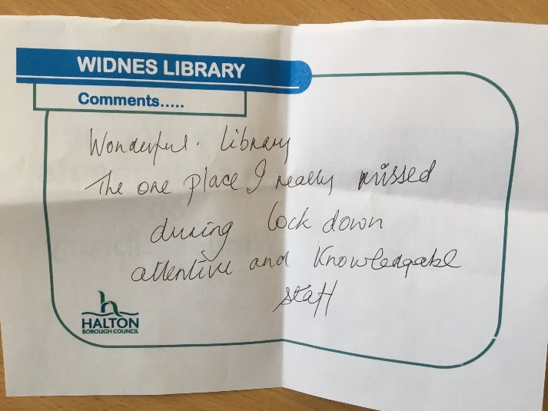

Ditton Library, Queens Avenue, Widnes, WA8 8HR
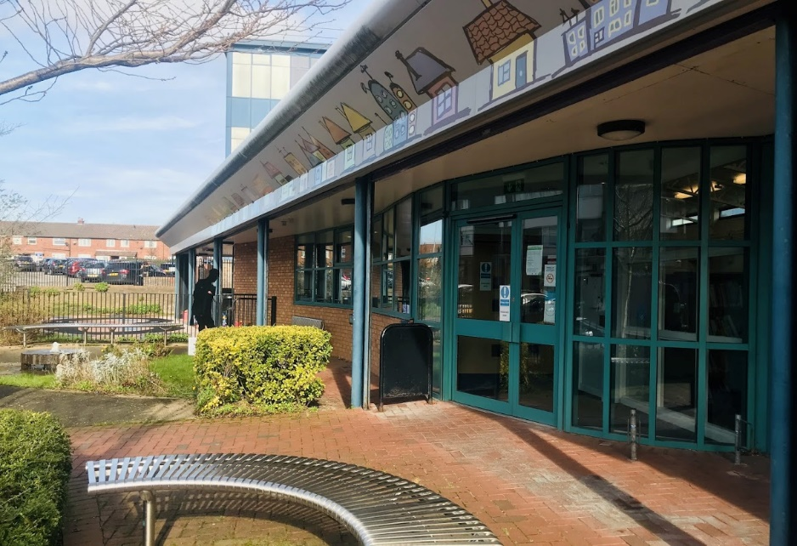
Contact details

Tel: 0151 424 2459
Runcorn Library, Granville Street, Runcorn, WA7 1NE
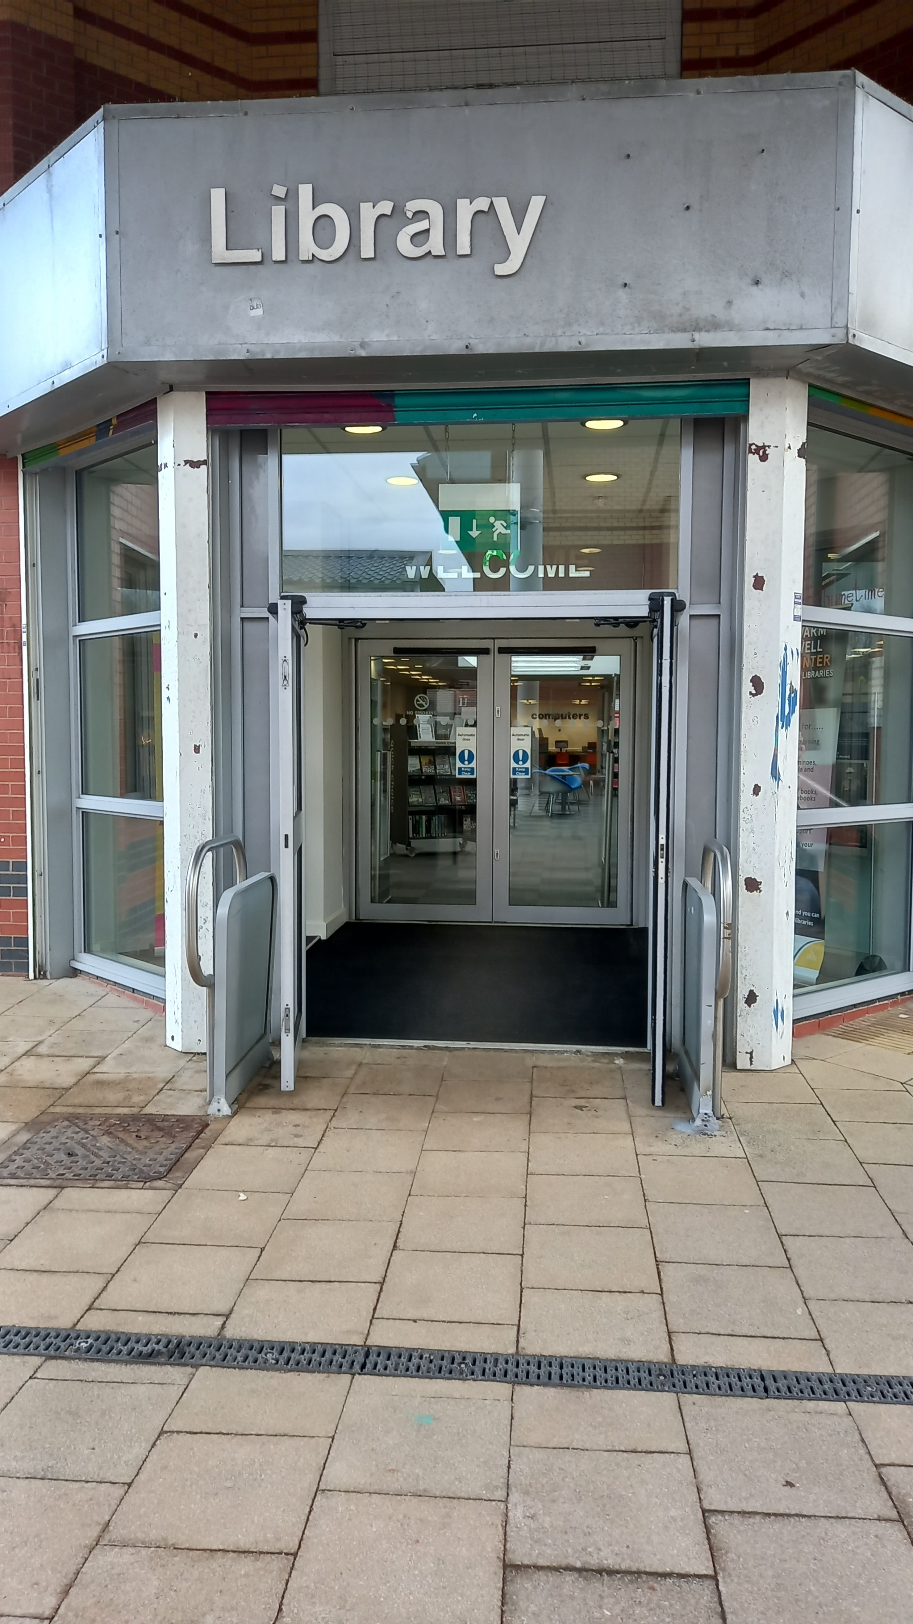
Contact details

Tel: 0151 511 7666
Widnes Library, Victoria Square, Widnes, WA8 7QY
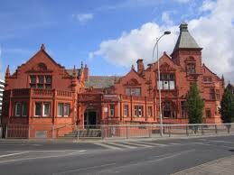
Contact details

Tel: 0151 907 8383
Email: widnes.library@halton.gov.uk
Halton Lea Library, Halton Lea, Runcorn, WA72PF
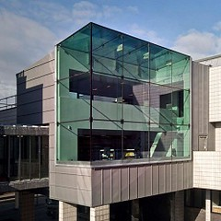
Contact details

Tel: 0151 511 7744
Email: haltonlea.library@halton.gov.uk

