Halton Lea Library
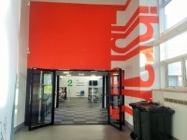

By Car
If driving, follow signs for Shopping City
Once here parking is FREE and holds 2,200 cars. There are blue badge parking spaces. Car Park 3 is the closest car park to Halton Lea Library.

By Bus
If you’re planning to travel by bus, the 3A, 3B, 3C, 14A, 20, 20A, 21, 52, 61A, 62, 62A, 66, 82A and X1 Halton bus services stop directly outside the Shopping City centre. Halton Lea Library is signposted.

By Train
Runcorn has two train stations: Runcorn and Runcorn East. They are accessible by bus or taxi.
Google Map for Halton Lea Library

Widnes Library

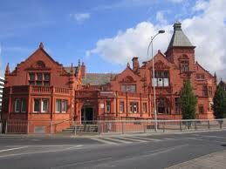

By Car
Parking is FREE and at the rear of the building. There are 2 blue badge parking spaces. There is also short stay parking available at the side of the building.
Parking is also available on Caldwell Road, near Riverside College.

By Bus
If you’re planning to travel by bus, the 82A, and 79C Halton bus services stop directly outside Widnes Library in Kingsway.

By Train
Widnes has two train stations: Widnes Central and Hough Green. They are accessible by bus or taxi.

Google Map for Widnes Library

Ditton Library
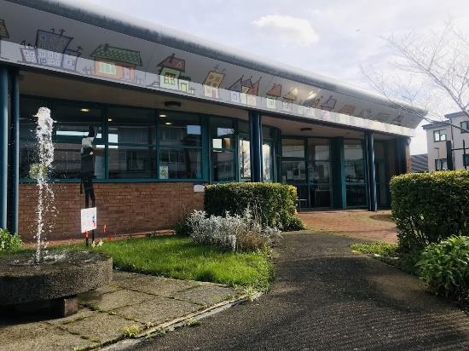

By Car
Parking is FREE and located at the rear of the library. There are 2 blue badge parking spaces within the car park.

By Bus
If you’re planning to travel by bus, 62 (Saturdays only) and 82A bus services stop near Ditton Library

By Train
Widnes has two train stations: Widnes and Hough Green. They are accessible by bus or taxi. Hough Green station to Ditton Library approximately 12 minute walk.

Google Map for Ditton Library

Runcorn Library
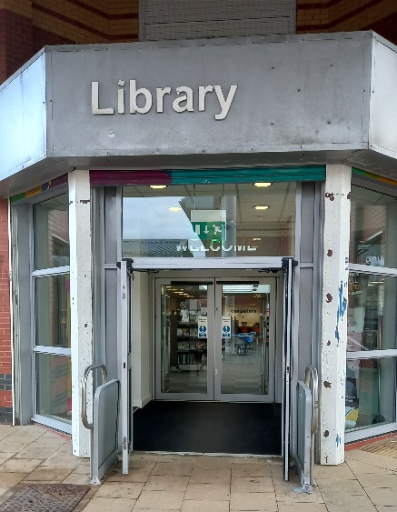

By Car
Parking is FREE in the nearby car parks on High Street.

By Bus
If you’re planning to travel by bus, the 3A, 3C, 3D, 20, 20A, 52, 61, 62, 62A, 66, 79, 82A, 110 and 200 Halton bus services stop close by Runcorn Library – 2 minute walk

By Train
Runcorn’s two train stations: Runcorn and Runcorn East are nearby with Runcorn station being a 9 minute walk away.
Google Map for Runcorn Library

