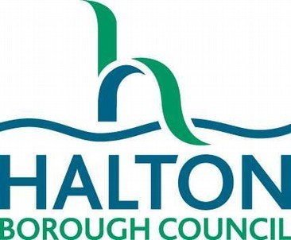
SCALE OF CHARGES
1st April 2020 – 31st March 2021
LIBRARY SERVICE

LOAN CHARGES
Talking Books Free of charge
Leisure Card Holders Free of charge
DVDs - Children’s collection Free of charge

Learning for Life Collection
Non-book items: Free of charge
Leisure Card Holders: Free of charge

FINES ON OVERDUE ITEMS

Books, Talking Books, CDs, and Learning for Life Collection
Adult tickets No charge
Leisure Card Holders No charge
Children’s tickets No charge
Young Persons tickets (16-18) No charge

LOST & DAMAGED ITEMS
Lost or damaged items will be charged for at the current replacement cost

RESERVATIONS
For items currently in stock Free of charge

Leisure Card Holders Free of charge

For items which have to be bought for stock
£2.50 per item
Leisure Card Holders £1.50 per item

For items which have to be obtained through Inter Library Loan or British Library
£11.00 per item
Leisure Card Holders £7.50 per item

PERSONAL COMPUTER BOOKINGS

Printing:
Black & White: 15p per page
Colour: 25p per page
Leisure Card Holders
Black & White: 10p per page
Colour: 15p per page

PHOTOCOPIES A4 - 15p per sheet
A3 – 25p per sheet
FAX
50p per sheet received
To UK: £1.00 first sheet
25p subsequent sheets
To Europe: £2.00 first sheet
50p subsequent sheets
International: £3.00 first sheet
£1.00 subsequent sheets

LOST TICKETS
Adults: £2.20
Children and Leisure Card Holders: £1.10

ROOM HIRE
Halton Lea:
Room | Standard Rate
 | 2020-21
Room 2 | £15.50 per hour
Room 3 | £15.50 per hour
Rooms 2 & 3 | £31.00 per hour
Room 4 | £9.00 per hour
Room 5 – ICT Suite | £15.50 per hour
Room 6 | £13.00 per hour
Meeting Room 7 | £10.00 per hour

Runcorn:
 | 2020-21
Meeting Room 8 | £12.75 per hour
Meeting Room 9 | £9.00 per hour
Meeting Room 10 | £9.00 per hour

